**Domestic Tourism**

The domestic tourism is growing day by day. Victoria and St. Catherine-Niagara falls most visited, more than 30% than any other place in throughout Canada during six years from 2011 to 2017(Figure 1). As per the statistic of Statistics Canada (n.d.), Ottawa-Gatineau, Toronto, Edmonton, and Calgary also attracted the mass of tourist during this period. On the other hand, tourists did not preferred to visited Regina, Halifax, and Saskatoon. The number of visited tourist for these regions is less than zero percentage (Figure 1) (Shkolnik, 2018)

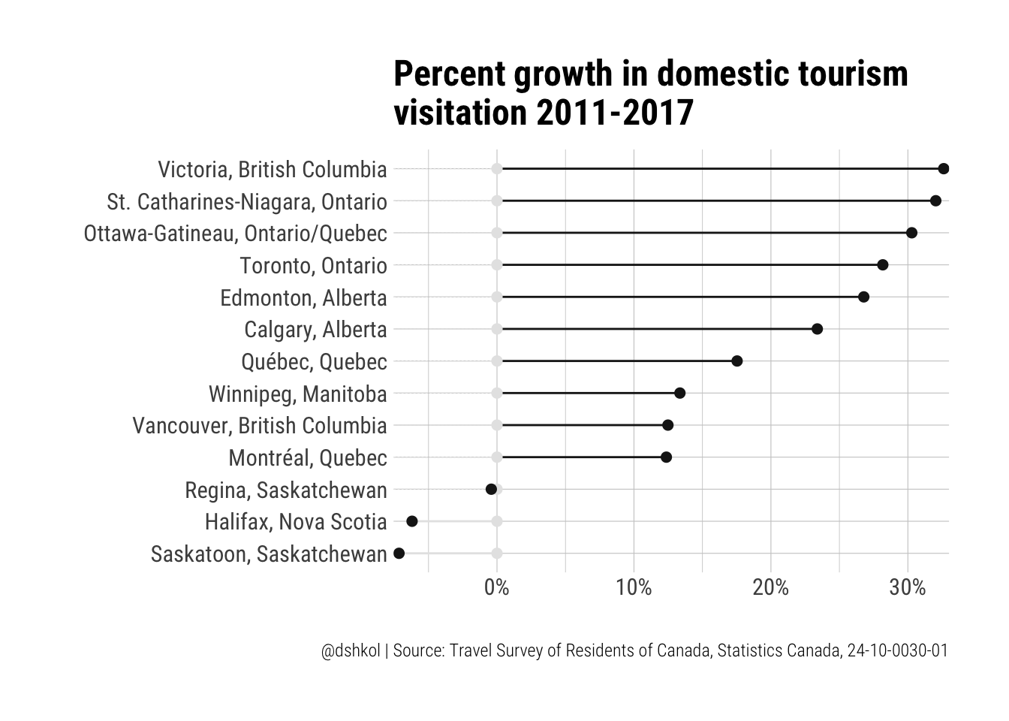

**Figure 1**: Percent growth in domestic tourism visitation 2011-2017(Statistics Canada, n.d.)

**References**

Shkolnik, D. (2018, August 1). The cansim package, Canadian tourism, and slopegraphs*.* Retrieved from <https://www.dshkol.com/2018/cansim-package-tourism-slopegraphs/>

Statistics Canada. (n.d.). Percent growth in domestic tourism visitation 2011-2017 [image]. Retrieved from <https://www.dshkol.com/2018/cansim-package-tourism-slopegraphs/>